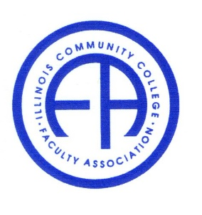
Illinois Community College Faculty Association

Friday, March 26, 2021 1:00 – 4:00 pm
Via Zoom Conference

Member present: Parul Raval, Stefanie Davis, Lauren Kosrow, Carla Presnell, Leo Welch, Keith Sprewer, Jake Winters, Julia DiLibert, Hong Fei

- Call to convene.

