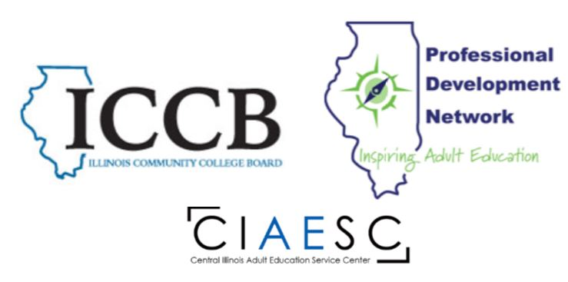
Overview of ABE/ASE Master Teacher Cohort 2022

Credentialed ABE/ASE Specialists are invited to participate in the ABE/ASE Master Teacher cohort, which runs from February – December 2022.
Participants must receive approval from their program administrators in order to participate in this cohort, and the appropriate verification documentation must be submitted to the Central Illinois Adult Education Service Center.
Completers will earn 20 hours of PD that can be distributed over two fiscal years, through a combination of virtual webinars, independent activities, and a special project. Certificates and PD hours will be provided upon approval of submissions, as applicable. When all documentation has been received and approved, the credential of ABE/ASE Master Teacher will be issued.

ABE/ASE (LA or Math) Master Teacher Cohort Overview
- Webinars will be scheduled based on participant availability

January – April 2022
Introductions
1 Virtual Webinar
2 Independent Activities

May – September 2022
1 Virtual Webinar
2 Independent Activities
October – December 2022
Completion of Special Project
1 Virtual Webinar (includes presentation of project)
Total of 20 professional development hours

